PNT2022TMID49260

12 NOVEMBER 2022

DATE

TEAM ID

PNT2022MID17430

Configure the application

|  |  |
| --- | --- |
| DATE | 12 NOVEMBER 2022 |
| TEAM ID | PNT2022TMID26841 |
| PROJECT NAME | HAZARDOUS AREA MONITORING FOR INDUSTRIAL PLANT POWERED BY IoT |

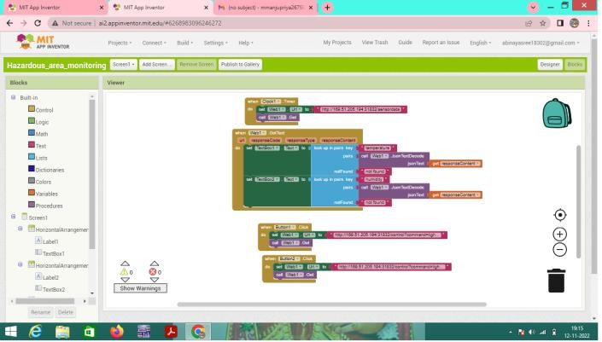Configure the application to receive the data from cloud:

PROJECT NAME

HAZARDOUS AREA MONITORING FOR

INDUSTRIAL PLANT POWERED BY IOT

# Configure the application to receive the data from cloud is creating successfully